## VIEWS ON THE FUTURE OF ARCHAEOLOGICAL ETHICS FROM THE 2020 SAA ETHICS SURVEY

Ben Marwick, Li-Ying Wang, Kaylee Pruski, Eloise Potter, and Raelee Hampton

Ben Marwick is Associate Professor in the Department of Anthropology at the University of Washington. Li-Ying Wang is a graduate student at the Department of Anthropology at the University of Washington. Kaylee Pruski and Raelee Hampton are undergraduate students at the Department of Anthropology at the University of Washington. Eloise Potter is a graduate of the Department of Anthropology at the University of Washington.

In the spring of 2018, the Society for American Archaeology (SAA) organized the Task Force on Revising the SAA Principles of Archaeological Ethics, Stage Two (TF-2), to survey the community about the Principles (see Rakita and Gordon, this volume, for more details about the work of TF-2). The survey was open to members and non-members from April to June of 2020, receiving a total of 1,542 responses (including 1112 SAA members). In this article, we focus on the results of four survey questions concerning the future of SAA’s documentation about ethics. We first identify the primary ethical concerns among the responses, then summarize responses on the purpose of the SAA's ethical document, and the types of ethical documents that respondents feel would best serve the SAA membership. Finally, we discuss how the SAA could respond to ethical concerns that were prominent throughout survey responses. We conclude that a closer relationship between the SAA and the Register of Professional Archaeologists (RPA) could efficiently address many concerns. A detailed description of our qualitative, statistical and computational methods is available in our online supplementary materials (<http://doi.org/10.17605/OSF.IO/643C8>). These materials include a compendium of R code used to produce the figures presented here (cf. Marwick et al. 2017), the full text of the survey responses (excluding personal data), and the full report submitted to the SAA Board of Directors.

## Primary Ethical Concerns

The survey question “What do you see as being the primary ethical concerns in the field today?” received more and longer responses than any other question in the survey, with a total of ca. 37,000 words in 455 responses. Topic modeling of these responses identified four prominent themes (Figure 1).

[insert Figure 1 near here, spread across two columns]

The most important theme was engagement with local and descendant communities. Qualitative data analysis (QDA) further indicated that this theme was concerned with the lack of involvement of Indigenous people in archaeological projects.The second theme was sexual, gender, and racial discrimination and equality. A close reading of responses showed that this theme reflects concern about senior archaeologists mistreating younger colleagues, and groups such as Indigenous communities, women, and minorities. The third major theme was cultural resource access and protection. QDA revealed concerns about looting and weak legal protection of the archaeological record, along with the desire for greater data sharing and open science practices between archaeologists. The fourth major theme was stewardship and education. A close reading of responses containing these themes shows concern about the failure to engage the public in archaeology; concern about delays in publication and sharing information, tensions about demands for data sharing; open science practices; and Indigenous sovereignty over archaeological sites, physical collections, and digital data.

## The Purpose of the SAA's Ethical Document

The most frequently first-ranked option in responses to the question about the purpose of the SAA's ethical document was “Establish best practices for the profession” (Figure 2). This was followed by “Establish and enforce best practices for the profession”. These rankings were consistent across most demographic categories, however, “Establish expectations of behavior” was more highly ranked by the non-binary respondents and respondents identifying with the LGBTQIA+ community (Figure 3). This pattern suggests that these minority populations in the SAA are more concerned about behavior and integrity than the majority groups. These groups likely rank that purpose higher because they are more vulnerable to negative impacts when behavior by others violates the Principles.

[insert Figure 2 near here, spread across two columns]

[insert Figure 3 near here, spread across two columns]

## Types of Ethical Document That Would Best Serve the SAA Membership

Six types of ethical documents were identified in the survey, more details about these can be found in Markert (this volume). The most popular option overall, was “Separate principles of ethics and standards of practice” (Figure 4). The most common pair of options was “Separate principles of ethics and standards of practice” and “Ethical documents that provide examples”. This indicates a preference for maintaining the current principles, but with regular additions of further documentation that provide more details, examples, and interpretation of the principles. This is consistent with the original framing of the Principles as ethical ideals or goals, as “ceilings” of ethical behavior (Lynott 1997), which may be compared to the Register’s codes and standards as the “floors” of professional conduct (Wylie 1996). To extend the building metaphor, what are needed now are “walls”, the documentation that connects the ethical ideals to the reality of practice.

[insert Figure 4 near here, spread across two columns]

Preference for types of ethical documents was strongly associated with the age of the respondents (Figure 5). Younger respondents highly ranked “A living document” and “Separate principles of ethics and standards of practice” while older respondents highly ranked “I am satisfied with the format of the current principles” and “An aspirational code.” This suggests a generational gap where older archaeologists are generally more satisfied, but younger archaeologists express a need for additional ongoing commentary and interpretation of the Principles. The “Satisfied” option was ranked very low by women and non-binary people, and respondents identifying as part of the LGBTQIA+ community, once again showing a negative response from minority demographics.

[insert Figure 5 near here, spread across two columns]

Respondents in CRM and members of the Register of Professional Archaeologists (RPA) more often highly ranked “I am satisfied with the format of the current principles” than respondents in academia, government, and non-members of the RPA. This may be because CRM archaeologists and RPA members are more likely to be aware of the Register’s Code of Conduct and its extensive and detailed Standards of Research Performance. Archaeologists who are aware of, and guided by, these RPA documents may find that they make up for any deficiencies in the less detailed Principles of the SAA, and so feel no need for any further documentation from the SAA.

## Additional Ethical Issues That Should Be Addressed by the Principles

Of the 1012 respondents to the yes/no component of this question, 22% answered “Yes”. Machine learning analysis of the 409 free text responses to the question “Are there additional ethical issues that should be addressed by the Principles?” identified four topics that were most abundant: sexual harassment, discrimination; digital data and human remains; and Indigenous communities’ rights (Figure 6). The first three of these also scored highly for exclusivity and coherence, indicating they are key topics of these responses.

[insert Figure 6 near here, spread across two columns]

## How to Respond to Concerns Raised in the Survey?

Reflecting on the survey responses, and the history of ethics documentation in the SAA, there are several possible measures available to the SAA to address concerns raised in the survey. We present here a selection of what we believe are the most practical options that the SAA should consider to efficiently address these concerns.

Several concerns surfaced by this survey might be more effectively addressed by structural and procedural changes in the SAA, rather than edits to the text of the Principles. For example, a major theme throughout the responses was the lack of enforcement and consequences for violators, which no amount of updates or additions to the Principles can address. Precedents for these kinds of action to address ethical concerns can be found, for example, in the 1991 adoption of an editorial policy by *American Antiquity* and *Latin American Antiquity* not to publish research on looted objects (Wylie 1996).

In the past, the *SAA Bulletin* published a regular commentary titled “Working together” that was a source of concrete ethical guidance on collaboration (Wylie 1999). The SAA should revive this concept in the form of a regular short column in the *Record,* focused on applied ethics more broadly. A starting point for contributions could be the key themes described in this report. This could be handled by a dedicated volunteer ethics editor, who might be drawn from the SAA’s Committee on Ethics, who solicits contributions from the membership. Other formats could include a web form for people to submit anonymous questions about ethics in archaeology, and a blog, with social media support, that responds to those questions (i.e. an advice column).

The SAA Committee on Ethics is charged with supporting ongoing discussion and review of archaeological ethics. However, this committee was not mentioned at all in responses to the survey, raising questions about the effectiveness and visibility of the committee. The Ethics Bowl, an annual debate competition for students that is organized by this committee, was favorably mentioned by five respondents. We recommend this committee take a more active and visible role in promoting the Ethics Bowl, organizing and sponsoring other meeting events, publications, and communications with members. The SAA Board of Directors should, according to the bylaws, "promote discussion and education about the ethical practice of archaeology," and thus assign this committee with specific work tasks that lead to more routine and impactful engagement with the SAA membership on ethical issues that are important to them.

The composition of this standing committee on ethics is another area where important improvements can be made in response to concerns identified in this survey. Our results show that concerns about ethics vary substantially among SAA members in different demographic categories. The committee on ethics should therefore include members from a wide variety of demographic categories to ensure adequate and diverse representation of the SAA members. One efficient way to accomplish this is to ask SAA interest groups to nominate a representative to be a member of the ethics committee. This would support the flow of information and ideas between different communities within the SAA membership and ensure the committee on ethics is responsive and transparent in its activities.

The free text responses to this survey generally indicate that SAA members have a strong desire for more specific ethical guidance and enforcement to punish violators. While the SAA already has a mechanism for this, the “Termination of Membership” procedures detailed in its Bylaws, this was not mentioned by survey respondents. Some respondents noted that the RPA was formed to supply the community with these more prescriptive ethical documents and grievance resolution infrastructure. Those respondents wrote positively about the RPA and were proud of their RPA membership. However, many respondents seemed unaware of the RPA. Wylie (2005) briefly describes the history of the RPA and notes that its emergence was partly because in the 1970s the SAA rejected proposals of a formal code of conduct governing archaeologists’ practice and grievance procedures to enforce this code. Our observation is that since that time, the RPA has been perceived by SAA members as only relevant to CRM work. An obvious step that the SAA should take is to promote greater awareness of the RPA and its ethical documentation and grievance resolution function. Since the SAA is a sponsor of RPA, a relationship already exists, and the survey responses suggest that SAA should aim for a much closer relationship between the two organizations. For example, the SAA should communicate an expectation that all SAA members working as professional archaeologists in any type of workplace (i.e. not just CRM archaeologists) should also become RPA members, and adopt the RPA Code of Conduct and Standards of Research Performance. Although RPA membership is already discounted for SAA members, additional actions here could include: a prominent recommendation to join RPA when SAA members renew their membership; free, regular advertising for RPA in SAA publications; RPA membership required for SAA board members, committee chairs, and task force chairs; and a formal collaboration between the two organizations so that the RPA grievance process can be used in tandem with the SAA Principles of Archaeological Ethics.

# Conclusion

The SAA Principles of Archaeological Ethics were drafted during a time of intense concern between the relationship of scientific archaeology, looting, expansion of the CRM field, and salvaged material (Lynott 1997; McGimsey 1995; Wylie 1996, 1999, 2005). The ethics of stewardship emerged as a response to these concerns and has strongly influenced the current Principles. While these concerns remain evident in the responses to this survey, our results show that they have been eclipsed by the emergence of an unmet need for ethical guidance, especially on interpersonal relationships (both internal and external to the discipline), and the power dynamics that shape those relationships. News media items and publications about the extent and effects of sexual harassment and bullying in archaeology are some of the most striking demonstrations of this need (e.g. Awesome Small Working Group 2019; The Collective Change 2019; Wade 2019; 2021). Additionally, responses to this survey indicate concerns about many other harmful power dynamics. In response to this, we propose an ethic of care (Held 2006; cf. Tronto 2005) as the motivating concept for revising the Principles, to ensure that vulnerable members of the community are not excluded from participation in archaeology. Revisions to the Principles willl help to enact an ethic of care (see Pruski et al. this volume), but a transformative implementation of an ethic of care in archaeology will require more than edits to the text of the Principles.

The National Academies of Sciences, Engineering, and Medicine (NASEM 2018) published a 2018 report, "Sexual Harassment of Women: Climate, Culture, and Consequences" that presented many detailed recommendations suitable for implementation by organizations such as the SAA. These include "Move beyond legal compliance to address culture and climate" and "Improve transparency and accountability". Many large scholarly and professional associations have already implemented these. For example, the Geological Society of America and the Paleontological Society adopted a program called RISE (Respectful Inclusive Scientific Events) that provided Society leaders and members with training in how to respond to specific instances of sexual harassment and other forms of unwelcome behavior (Mogk 2018). Our results suggest that the SAA could greatly benefit from following the example of other peer organizations that have taken a head start in implementing the recommendations of the NASEM report. Colaninno et al. (2020) have provided some guidance on implementation of NASEM recommendations in archaeological field school contexts that could also be more broadly applied in other contexts where archaeologists work.

While the issue of sexual harassment is a challenge that is shared by many disparate scientific communities, the theme of Indigenous people in the research process is a longstanding point of tension that is a more distinctive challenge for the archaeological community. Our results suggest that the archaeological community generally supports a greater recognition of the special status of Indigenous, descendant, and local communities in the archaeological process. Our results also show uncertainty in how best to recognize this special status (cf. González-Ruibal 2018). The survey data indicate that the regular publication and discussion of brief exemplary vignettes of good practice will be a highly effective way to converge on norms of practice that respond to these concerns.

A limitation of this survey is the sample size and the relatively low level of representation of the archaeological community. With 1,542 responses to the survey and an estimated 6,500 members of the SAA, we have responses from less than 20% of the membership. That said, the sample here is nearly double that of the most recent membership needs survey that collected 839 responses. Furthermore, the survey we report on here is, as far as we know, the largest survey ever conducted on archaeological ethics. This survey is strengthened by its qualitative analyses where text input has provided some greater insights into causality and relationships that more quantified and tabulated summaries of data cannot (see Pruski et al. this volume). Our use of machine learning methods to automatically extract topics from the free text responses provides robust independent support of the findings from our qualitative data analysis of survey responses.

A less obvious limitation on the effectiveness of surveys such as these is the distinctive approach that the SAA has historically taken to demarcation questions (What is archaeology? What is an archaeologist?). Historically, the SAA has operated in the model of scholarly society, not a professional association, and resisted drawing a line between professionals and non-professionals, for example, by refusing to codify professional standards to define who an archaeologist is and how their practice should be defined (McGimsey 1995). However, our results show that there is a strong desire among archaeologists for more firm demarcation between professional and unprofessional archaeological work and behavior, and a desire for consequences (i.e. exclusion from the professional community) for people who violate standards. The history and culture of the SAA as a scholarly society poses a substantial challenge to addressing these concerns. A much closer relationship between SAA and the RPA will be a productive path towards more specific ethical guidance and enforcement of ethical principles.

References Cited

Awesome Small Working Group

2019 Take Back the SAA: Member-Led Organizing and Action in the Wake of

#SAA2019. *SAA Archaeological Record* 19(4):16-21.

Clancy, Kathryn B. H., Robin G. Nelson, Julienne N. Rutherford, and Katie Hinde  
 2014 Survey of Academic Field Experiences (SAFE): Trainees Report Harassment and

Assault. *PLOS ONE* 9(7):e102172. DOI:10.1371/journal.pone.0102172.

Colaninno, Carol., Lambert, Shawn, Beahm, Emily, & Drexler, Carl

2020 Creating and Supporting a Harassment- and Assault-Free Field School. *Advances*

*in Archaeological Practice*, 8(2), 111-122. doi:10.1017/aap.2020.8

González-Ruibal, Alfredo  
 2018 Ethics of Archaeology. *Annual Review of Anthropology* 47:345–360.

Held, Virginia

2006 *The Ethics of Care: Personal, Political, and Global*. Oxford University Press. Oxford

Lynott, Mark J.  
 1997 Ethical Principles and Archaeological Practice: Development of An Ethics Policy.

*American Antiquity* 62(4):589–599.

Marwick, Ben, Carl Boettiger, and Lincoln Mullen

2018 Packaging data analytical work reproducibly using R (and friends). *The American*

*Statistician* 72(1):80–88. DOI:10.1080/00031305.2017.1375986.

McGimsey, Charles R.  
 1995 Standards, Ethics, and Archaeology: A Brief History. In *Ethics in American Archaeology: Challenges for the 1990s*. edited by Mark J. Lynnott and Alison Wylie (eds.),

pp. 11–13. Washington D.C.: Society for American Archaeology.

Meyers, Maureen, Tony Boudreax, Stephen Carmody, Victoria Dekle, Elizabeth Horton, and Alice Wright  
 2015 Preliminary Results of the SEAC Sexual Harassment Survey. In *Horizon and Tradition:*

*The Newsletter of the Southeastern Archaeological Conference*, 57(1): 19–35.

Meyers, Maureen S, Elizabeth T Horton, Edmond A Boudreaux, Stephen B Carmody, Alice P Wright, and Victoria G Dekle  
 2018 The Context and Consequences of Sexual Harassment in Southeastern Archaeology.

*Advances in Archaeological Practice* 6(4):275–287.

Mogk, David W.  
 2018 Geoethics and Professionalism: The Responsible Conduct of Scientists. *Annals of*

*Geophysics* 60(7):1–12.

NASEM  
 2018 *Sexual Harassment of Women: Climate, Culture, and Consequences in Academic*

*Sciences, Engineering, and Medicine*. National Academies Press. Washington DC

Nelson, Robin G., Julienne N. Rutherford, Katie Hinde, and Kathryn B. H. Clancy  
 2017 Signaling Safety: Characterizing Fieldwork Experiences and Their Implications for

Career Trajectories. *American Anthropologist* 119(4):710–722.

Radde, Hugh D.  
 2018 Sexual Harassment among California Archaeologists: Results of the Gender Equity and Sexual Harassment Survey. *California Archaeology* 10(2):231–255.

The Collective Change

2019 #MeToo in Archaeology. *SAA Archaeological Record* 19(4):12-15.

Tronto, Joan  
 2005 An Ethic of Care. In *Feminist theory: A Philosophical Anthology.* Edited byAnn

E. Cudd and Robin Andreasen (eds.), pp. 251–263. Wiley-Blackwell. Oxford

VanDerwarker, Amber M., Kaitlin M. Brown, Toni Gonzalez, and Hugh Radde  
 2018 The UCSB Gender Equity Project: Taking Stock of Mentorship, Equity, and Harassment in California Archaeology Through Qualitative Survey Data. *California Archaeology* 10(2):131–158.

Wade, Lizzie

2021 Use of Nazi salute rocks archaeology conference. *Science*.

<https://www.sciencemag.org/news/2021/01/public-use-nazi-salute-rocks-archaeology-conference>,

accessed February 5, 2021.

Wade, Lizzie, 2019  
 2019 #MeToo Controversy Erupts at Archaeology Meeting. *Science*. <https://www.sciencemag.org/news/2019/04/metoo-controversy-erupts-archaeology-meeting>,

accessed January 27, 2021.

Watkins, Joe  
 2012 The Pipelines of Archaeological Ethics as a Living Document: Is Revision Necessary?

*SAA Archaeological Record* 12(2):27–44.

Wylie, Alison  
 1996 Ethical Dilemmas in Archaeological Practice: Looting, Repatriation, Stewardship, and the (Trans) Formation of Disciplinary Identity *Perspectives on Science* 4(2):154–194.

1999 Science, Conservation, and Stewardship: Evolving Codes of Conduct in Archaeology.

*Science and Engineering Ethics* 5(3):319–336.

2005 The Promise and Perils of an Ethic of Stewardship. In *Embedding Ethics*. Edited by Lynn Meskell and Peter Pels (eds.), pp. 474–468. Berg Oxford.

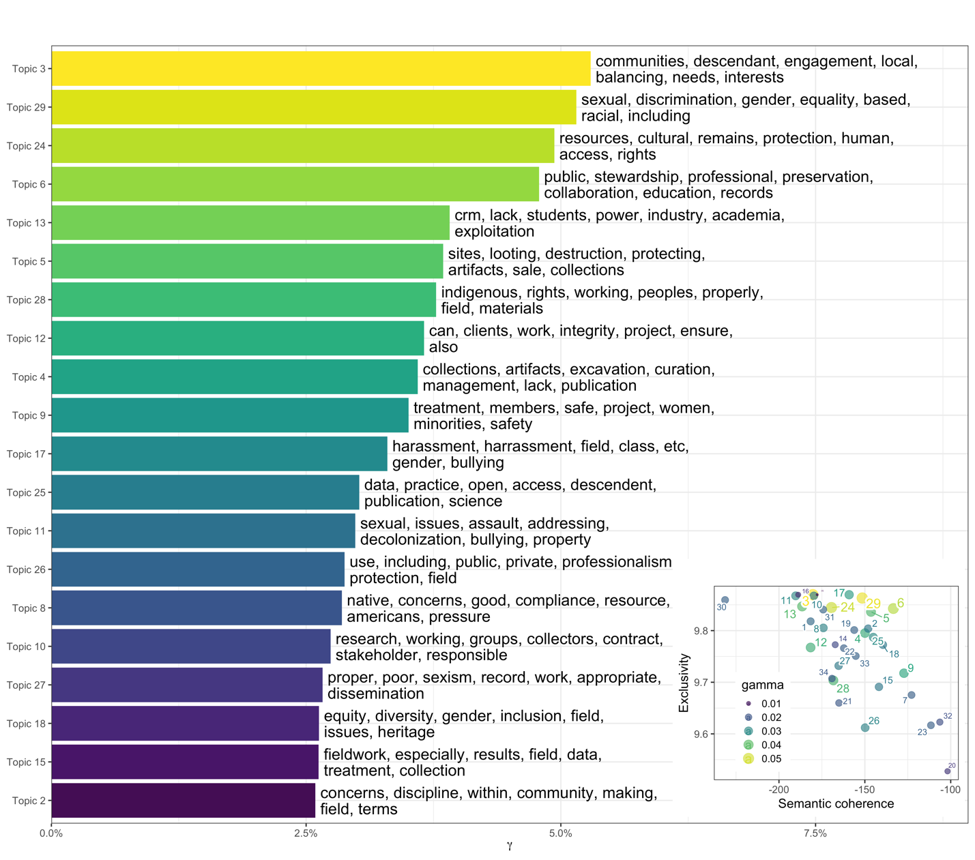

Figure 1. Machine learning analysis of the 455 free text responses to the question “What do you see as being the primary ethical concerns in the field today?” Main panel: The top 20 topics automatically detected by topic modelling, ranked by their prevalence in the text, and with the seven most popular words for each topic shown. Topics at the top are more common in the responses. Inset: plot of topic exclusivity and semantic coherence. Topics in the upper right are more distinctive and interpretable. For more details on our topic modelling analysis, see our online supplementary materials (<http://doi.org/10.17605/OSF.IO/643C8>)

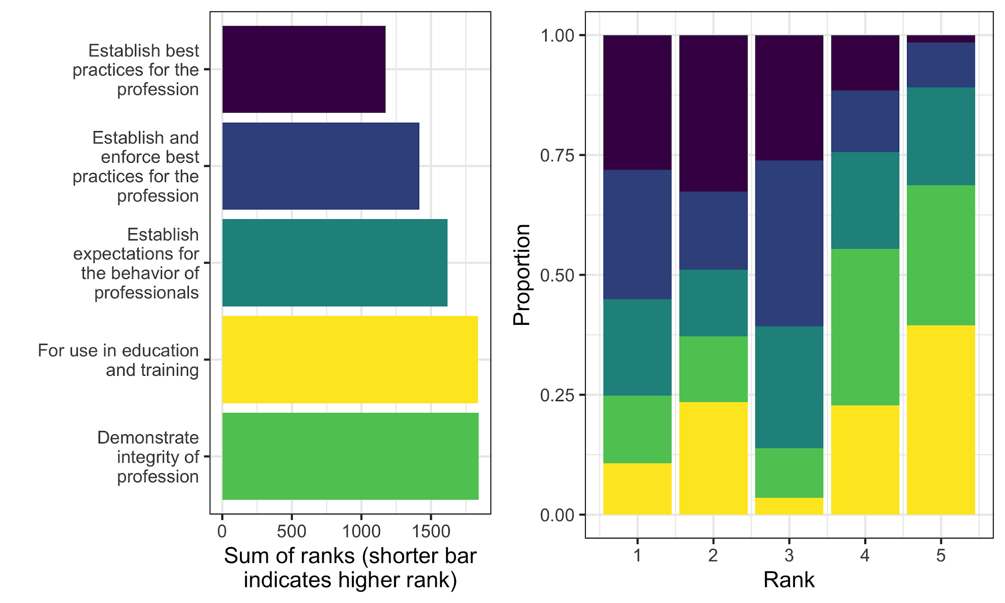

Figure 2. Left: Summary of ranks of options for the question about what should be the purpose of the SAA’s ethical document. Right: Proportions of each option selected as first-ranked, second-ranked, etc.

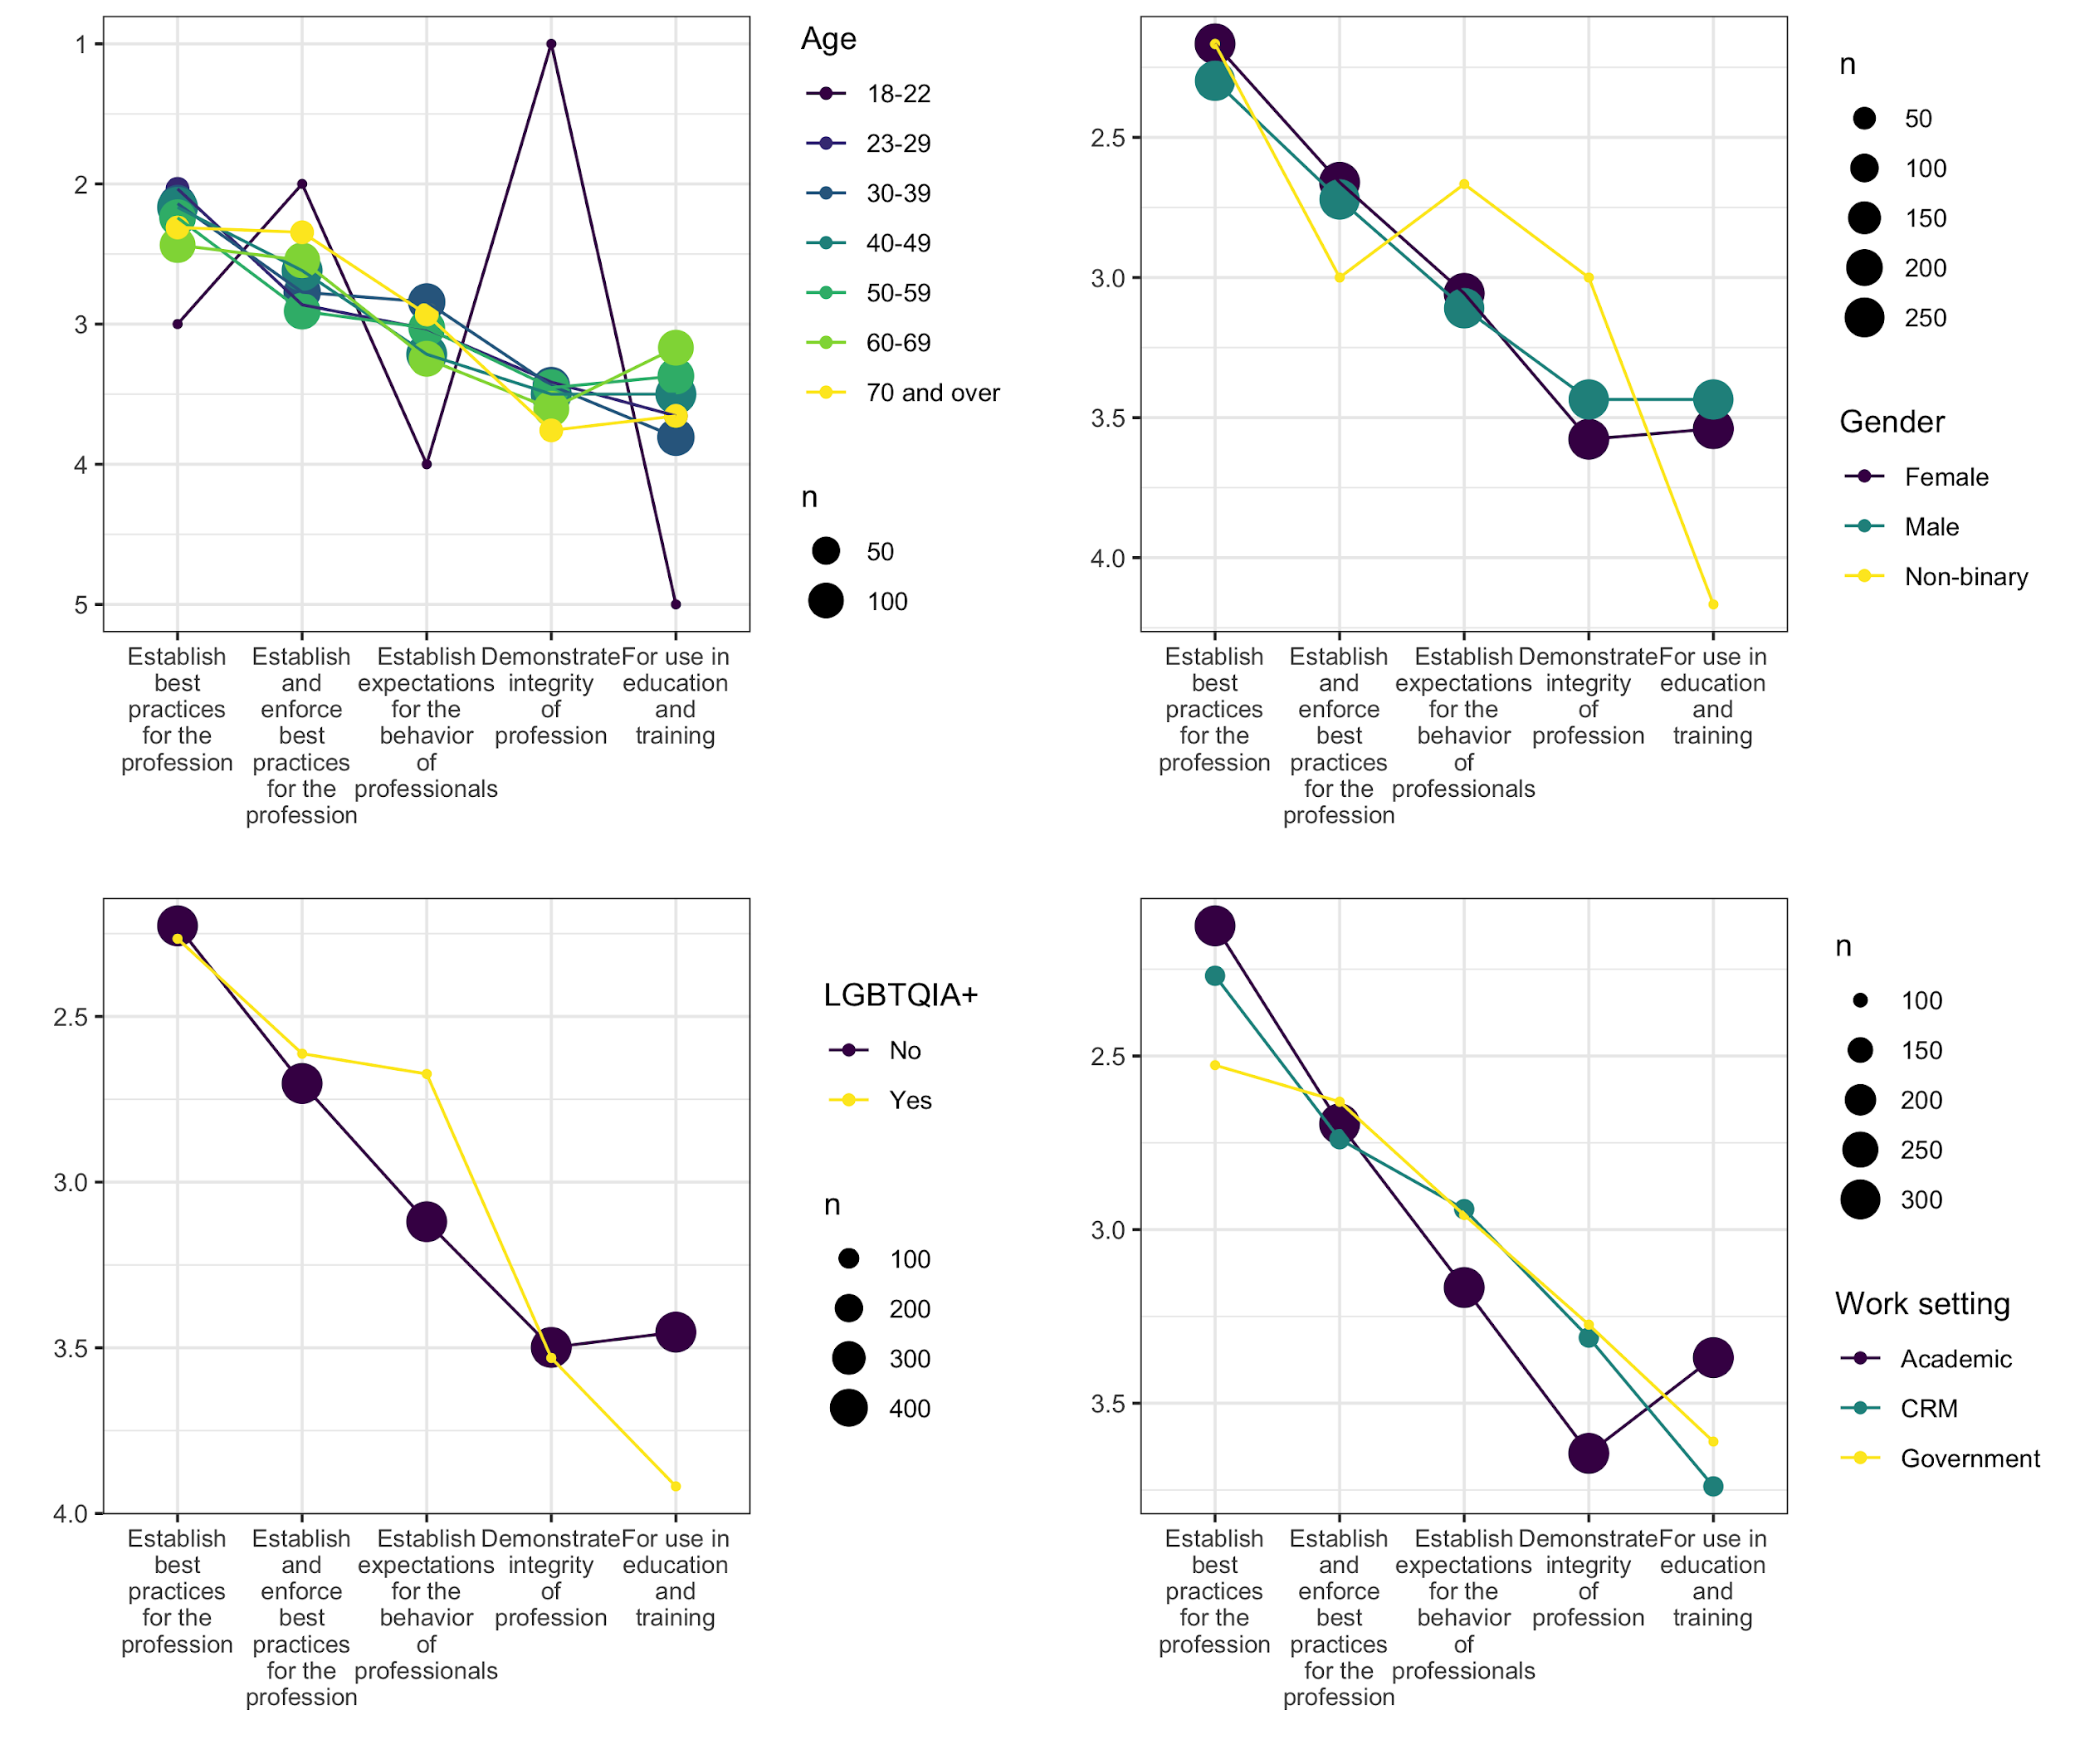

Figure 3. Average ranking of each option for selected demographic categories responding to the question about the purpose of the SAA's ethical document. Vertical axis indicates the proportion of respondents in each category selecting each of the six options presented for this question. The size of each data point is scaled to the number of respondents in each category.

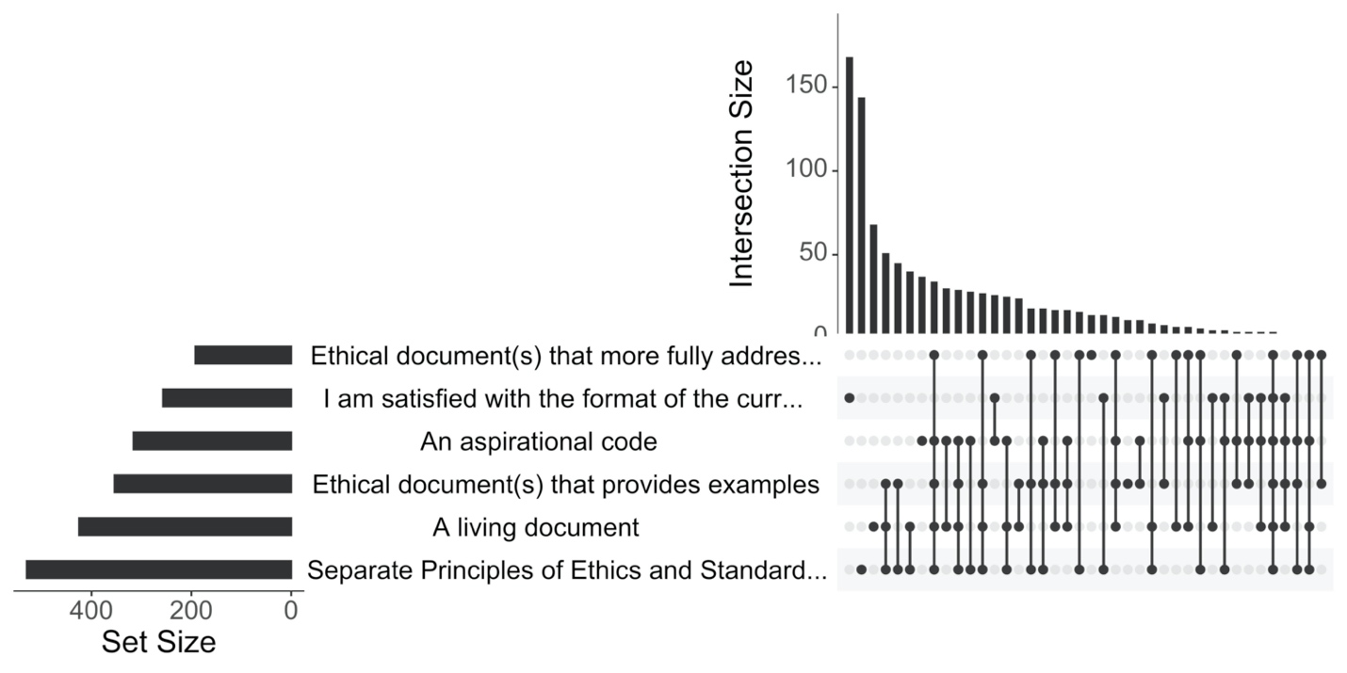

Figure 4. UpSet plot of the respondents to the multiple choice question about what type of ethical document(s) do you feel would best serve the SAA membership

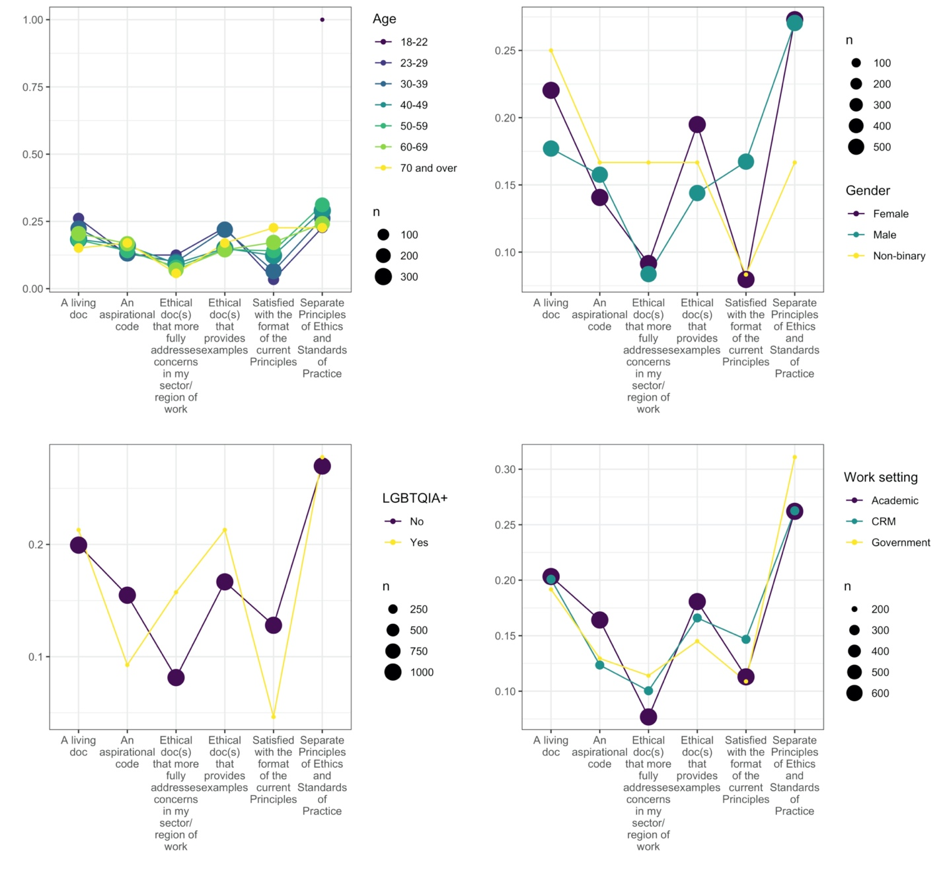

Figure 5. Average ranking of each option for a selection of demographic categories responding to the question about what type of ethical document(s) do you feel would best serve the SAA membership. Vertical axis indicates the proportion of respondents in each category selecting each of the six options presented for this question. The size of each data point is scaled to the number of respondents in each category.

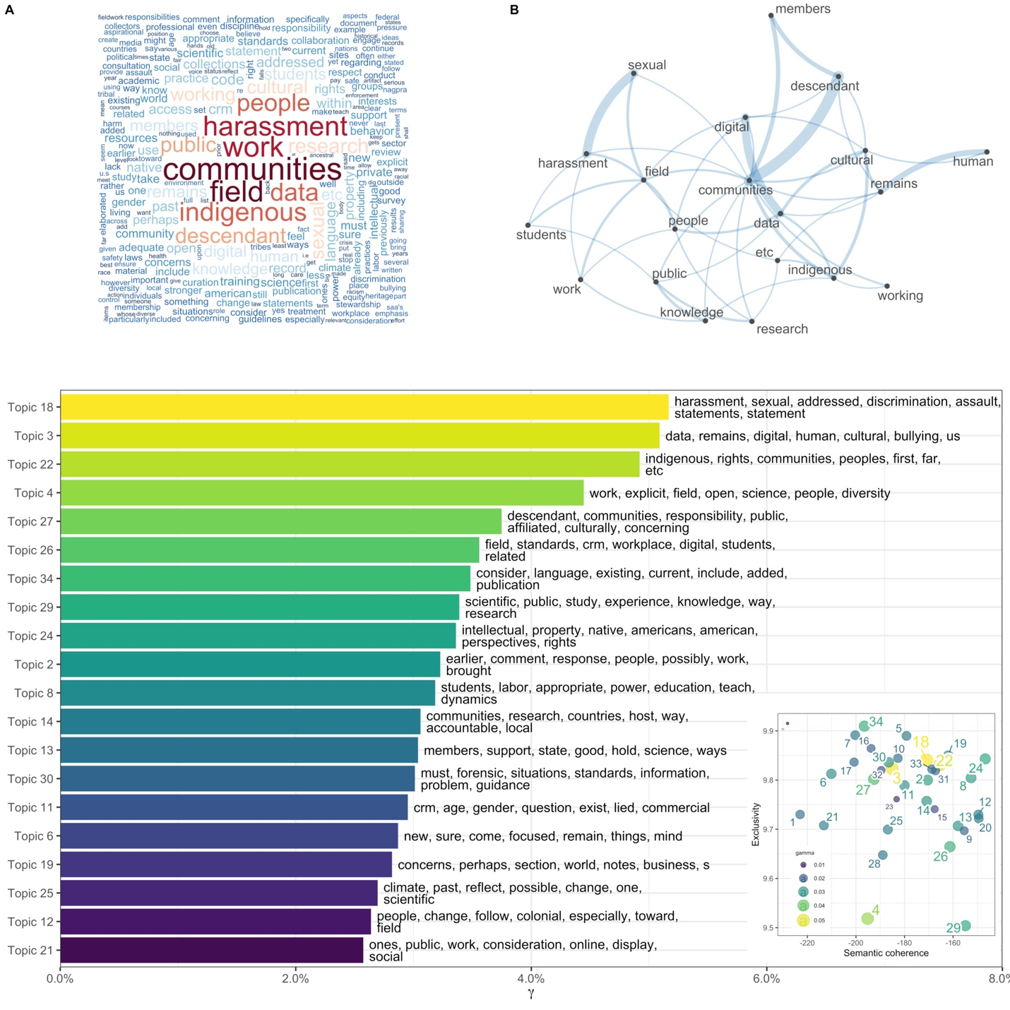

Figure 6. Summary of computational analysis of the 409 text responses submitted for the question “Are there additional ethical issues that should be addressed by the Principles?” A: word cloud that scales the size of a word proportional to how frequently it appears in the responses. B: a network plot showing how highly frequent words co-occur in the responses. Lower main panel: The top 20 topics identified by machine learning, ranked by their prevalence in the text, and with the seven most popular words for each topic shown. Topics at the top are more common in the responses. Inset: plot of topic exclusivity and semantic coherence. Topics in the upper right are more distinctive and interpretable. For more details on our topic modelling analysis, see our online supplementary materials (<http://doi.org/10.17605/OSF.IO/643C8>)